## SOFTWARE QUALITY ASSURANCE MANAGEMENT

## NAME:S.Logitha

## REG NO:192121138

## 3.UML DIAGRAM FOR ONLINE VOTING SYSTEM

## AIM:

To draw UML diagram for Online voting system using Umbrello tool

## PROBLEM STATEMENT:

Develop a scenario based modeling and draw the appropriate use case diagrams for the below given “Online Voting System”. Internet has led to discussion of e-democracy and online voting. Many peoples think that the internet could replace representative democracy, enabling everyone to vote on everything and anything by online voting .Online voting could reduce cost and make voting more convenient. This type of voting can be done for e-democracy, or it may be used for finalizing a solution, if many alternatives are present. Online voting make’s use of authentication, hence it needs security, and the system must be able to address obtaining, marking, delivering and counting ballots via computer. Advantage of online voting is it could increase voter turnout because of convenience, and it helps to reduce fraud voting.

**USE CASE SCENARIOS**:

**The voter scenarios are:**

* The voter login to the system.
* The voter can begin to vote at any time.
* We have only 1 change to change a vote
* Caste vote
* View online help

## Admin scenario arc:-

* Admin can login to the system
* Admin has a activities like update and delete or add new candidate
* File can give the results of the elections
* He can filter the results
* He have the permissions like modified the voter profile etc

**Login:**-Both the admin and valid voter can login into the system. The admin should provide a password and login ID to the voters before the election starts

**Voter profile:-**The voter can seen their profile but changes not be done by the voter only admin can change the voter profile

**Add candidate:-**The admin can have the permissions like to add the candidate or update the details of the candidate

**Caste vote:-**The voter can use the vote on the day of polling can be due to their respective candidate

## USE CASE DIAGRAM:

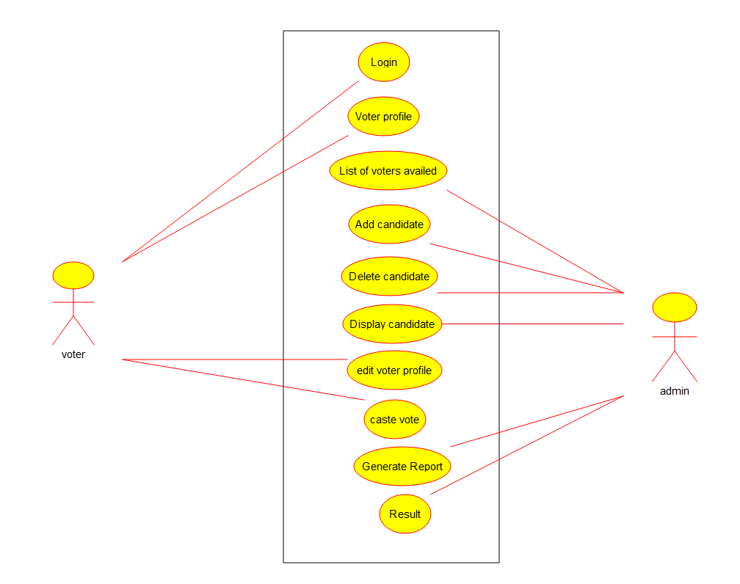

**CLASS DIAGRAM:**

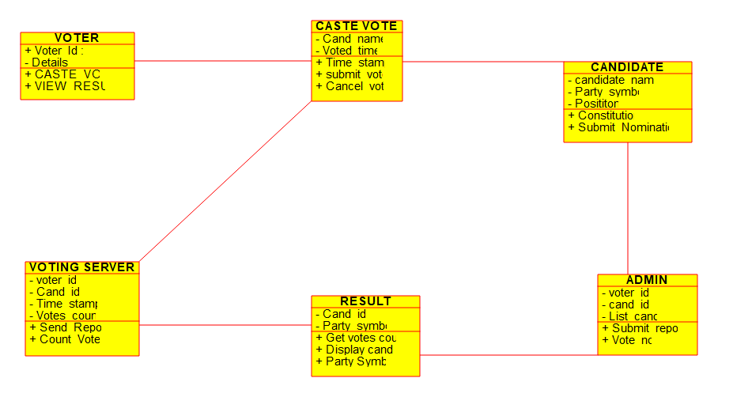**SEQUENCE DIAGRAM:**

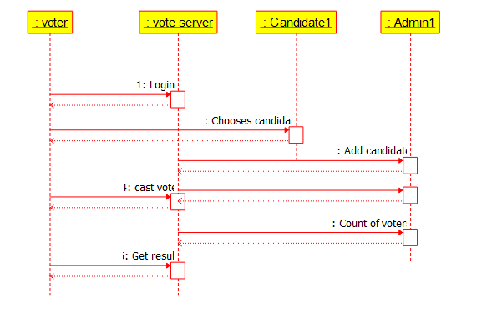

**ACTIVITY DIAGRAM:**

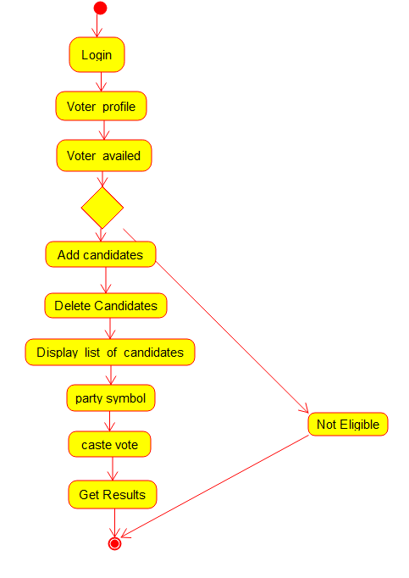

## RESULT:

Thus the use-case diagram for online voting system is drawn and verified successfully.